MA684 Homework from Class 4
Multiple linear regression

This material is covered in Chapter 8 and 9 of KKM and N. Sections 8.1 – 8.5 give background information on the theory of multiple regression. Sections 8.6 and 8.7 give more practical examples of multiple regressions. Chapter 9, sections 9.1 – 9.3 discuss the overall F-test for multiple regression and the partial F-test for a single variable.

1. Based on data presented in KKM and N, Chapter 8. To study a medical condition that leads to high cholesterol levels, a sample of n=25 patients with the condition was enrolled. We are interested in how age (in years) and weight (in kilograms) related to cholesterol levels in these patients, and will investigate through multiple linear regressions.

Summary data from the sample and the results of the multiple regression follow:

Table 1. Means and standard deviations of study variables (n=25 patients)
Variable | Mean | Std Dev
Age  Weight  Cholesterol | 39.1  68.7  310.7 | 12.2  12.7  77.8

Table 2. Summary of the multiple linear regression predicting total cholesterol level from age and weight
 | Parameter  Estimate | SE | t-value | p-value
Intercept  Age  Weight | 77.98  5.22  0.42 | 52.43  0.73  0.76 | ---  6.89  0.57 | <0.001  0.573

Table 3. Partial results for the ANOVA table from this multiple regression are:
Source | SS | d.f. | MS | F
Model  Error | 102,571  42,806 | 2  22 | 51285.5  1945.7 | 26.4
Total | 145,377 | 24

1A. Complete the above ANOVA table.
- Find and interpret the R-square from this multiple regression.
- What null hypothesis is being tested by the F-statistic from the Anova table?
- Find and interpret the p-value from the F-statistic from the ANOVA table.
Answer:
R²=102571/145377=0.706
Null Hypothesis: For the ANOVA for the regression is that there is no association between high cholesterol levels and any of the variables in the regression model.
With two variables in the model and a sample of n=25, there are 2 and 25-2-1 = 22 degrees of freedom for the F-statistic. From Excel (=f.dist.rt(26.4,2,22) ), p=1.4247E-06. Since this p-value is below the conventional 0.05, we can conclude that at least one of the variables in the model is significantly associated with high cholesterol levels.

1B. What are the degrees freedom for the t-statistics for the slopes for age and weight in Table 2? What can you conclude about the associations between age, weight, and cholesterol levels from Table 2?
Answer:
For age and weight, the degrees of freedom for the t-statistic are n-k-1 = 25-2-1=22 (the same as the degrees freedom error in the ANOVA table). At the conventional 0.05 level, there is significant association between age of the high cholesterol levels. But there is no significant association between weight of the high cholesterol levels.

1C. Calculate the standardized regression coefficients for age and weight for the multiple regression presented in Table 2. What can you conclude from these standardized regression coefficients?
Answer:
Age: 5.22*12.2/77.8=0.8186
Weight: 0.42*12.7/77.8=0.0686
Since the absolute value of the standardized slope is greater for the age, the age is a stronger predictor of high cholesterol levels than is the weight.

2. See the Quality of Life data set from Homework 3. We want to examine the associations between education (educyears, coded as years of education), income (in thousands of dollars), and the size of one’s social network (the number of people you could turn to in troubled times) and perceived quality of life (qol, with higher values indicating better quality of life).

Run the multiple regression predicting quality of life from education, income, and the size of the social network (in this order).

2A. Complete the following summary table:

 | Parameter  Estimate | SE | t-value | p-value | 95% CI
Intercept  Education  Income  Social Network | 30.5498  5.5196  0.4850  9.1917 | 49.0669  2.8718  0.4311  2.4468 | 0.623  1.922  1.125  3.757 | 0.5350  0.0576  0.2634  0.0003 | (-66.8470855, 127.946782)  (-0.1808394, 11.220126)  (-0.3707421, 1.340751)  (4.3348338, 14.048505)
R² = 0.1891 , F = 7.461 , p = 0.0001527
Df=96
T-critical value=1.985
2B. Give a summary of your findings presented in 2A, including an interpretation of the R² and p-value from the Anova table for the regression, and the slopes and p-values for the three predictors in the model.

R-square = 0.1891, so this set of independent variables explain 18.91% of the variability in quality of life.
F=7.461, giving p=0.0001527. At least one of the independent variables in the model is significantly associated with quality of life.
> sd(educyears)
[1] 2.826623
> sd(income)
[1] 18.75362
> sd(socialnetwork)
[1] 3.253266
> sd(qol)
[1] 84.72146

Educyears: 5.5196*2.826623/84.72146=0.1844
Income: 0.4850*18.75362/84.72146=0.1074
Socialnetwork: 9.1917*3.253266/84.72146=0.3532

Since the absolute value of the standardized slope is greater for the Socialnetwork, the Socialnetwork is a stronger predictor of quality of life than is the educyears and income.

2C. To describe the relative importance of the three predictors in the model, complete the following table of the contributions to R² (or partial R² ‘s):
Variable | Type 1  Contribution to R² | Type 2  Contribution to R²
Education  Income  Social Network | 0.0672  0.0027  0.1192 | 0.0312  0.0000  0.1192

It is intended that you calculate these contributions to R² by running separate regression models, and comparing the Model R² ‘s from these models.
- What is the difference in the interpretation of Type 1 vs. Type 2 partial R² ?
- Based on the Type 2 partial R² ‘s, which is the strongest predictor of quality of life? Give an interpretation of the partial R² for this variable.
Answer:
Type1:
For educyears: R²= 0.06717
For educyears & income: R²=0.06986
For educyears & income & Social Network: R²=0.1891

Type2:
For educyears & income & Social Network: R²=0.1891
For educyears & income: R²=0.06986
For Social Network & income: R²=0.1579

The Type1 is based on one variable, and add others one by one in order to compare.
The Type2 is based on all variables and compare with other which reduced one variable.

Based on the Type 2 partial R² ‘s, Social Network is the strongest predictor of quality of life.

2D. Perform a partial F-test corresponding to the Type 2 partial R² for education (that is, testing the contribution of education, after controlling for income and social network). Give the F-value, degrees freedom, and p-value for this test, and provide an interpretation of your result. How does this result relate to the test for the slope for education in the summary table you gave in Part 2A?
Answer:
Partial R²=0.1891-0.1579=0.0312
F-statistic F= 3.69 with df 1,96
P-value= 0.0577

Because P-value>0.05. for the contribution of education after controlling for income and social network. There is significant association between them.

2E. Perform a partial F-test corresponding to the Type 1 partial R² for income (that is, testing the contribution of income, after controlling for education). Give the F-value, degrees freedom, and p-value for this test, and provide an interpretation of your result.
Answer:
Partial R²=0.06986-0.06717=0.0027
F-statistic F= 0.28 with df 1, 96
P-value=0.598

Because P-value>0.05. For the contribution of income after controlling for education. There is significant association between them.

A note about ANOVA tables for Multiple Regression in R:

In both SAS and SPSS, the Anova table for a multiple regression groups the ‘source’ of variability as the ‘Model/Regression’ and ‘Error/Residual’:

For example, for the multiple regression in 2A, SAS gives the Anova table as:
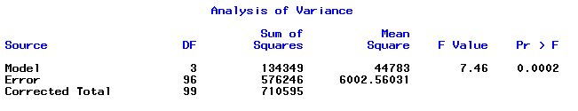

SPSS gives the Anova table as:
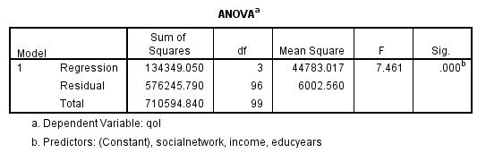

R gives the model R-square, F-test, and p-value as part of the basic ‘summary’ of the linear regression. The ‘summary.aov( )’ command asks for the Anova table for the regression, but R gives it in a different format – R breaks down the ‘Model’ sums of squares into what can be explained by each of the variables in the model, and doesn’t give a row for the total sum of squares:
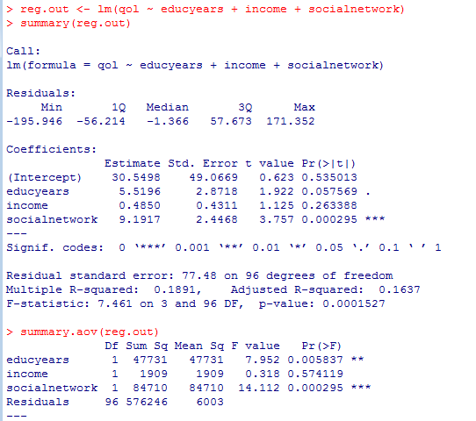

The ‘residual’ row in R agrees with the ‘residual’ row in SPSS and the ‘Error’ row in SAS. The rows in R’s Anova table correspond to the Type 1 sequential sums of squares for each variable in the model – they are the sums of squares added to the model as education, income, and social network are added. To get the total sum of squares for the model (which is what we’ve been working with in class), you can sum these sums of squares (and sum the degrees freedom):

47731 + 1909 + 84710 = 134350 with 3 df (which agrees within round-off errors with the Model sums of squares from SAS and SPSS).

The total sum of squares can then be calculated from the model and residual/error sums of squares:

134350 + 576246 = 710596 (which again agrees within round-off)

So, R users may need to do a little more work to obtain the version of the Anova table for the regression that we have been using in class. (Although you can easily calculate the Type 1 contributions to R-square from R’s version of the Anova table, so you may save some time there.)

